Business development aid for market and production disturbances caused by the coronavirus pandemic

Application for payment
In order to fill in and submit the payment application, you need to have one of the following roles in the company/organisation you are representing: authority to sign, private trader, general partner, executive director, or the authorisation to apply for company funding on behalf of the company.
→ Log in to the regional administration e-service. Open the e-service from the “TYÖPÖYTÄ” (Desktop) page under “Meneillään oikea asiointi” (Current business).
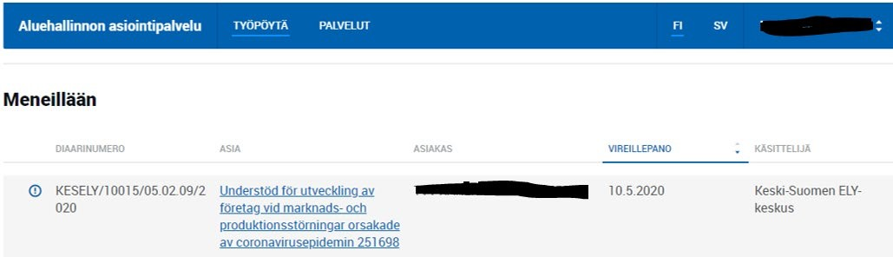
This opens the e-service space for the application in question, in which you can see the original application (HAKEMUS page), the decision received (PÄÄTÖS page) and the payments (MAKSATUKSET page).

The application for payment is initiated by pressing the “MAKSATUS” (Payment) button, which opens the actual application for payment.

Application for payment for situation analyses
The application for payment for situation analyses is composed of four tabs. Mandatory fields are marked with an asterisk (*).
“PERUSTIEDOT” (Basic details) tab
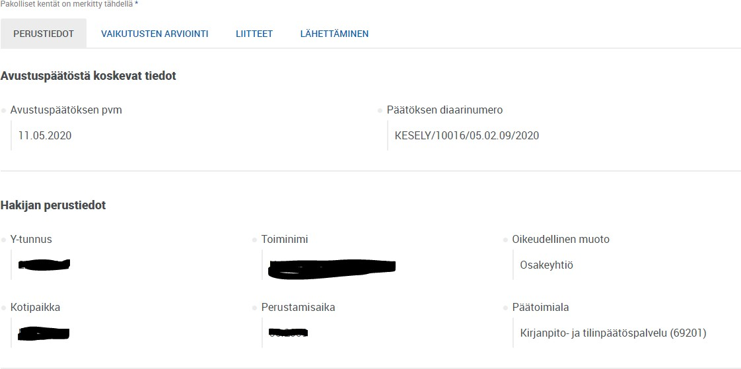
The applicant’s basic data are retrieved from the Business Information System (YTJ), and this information cannot be changed within this application.
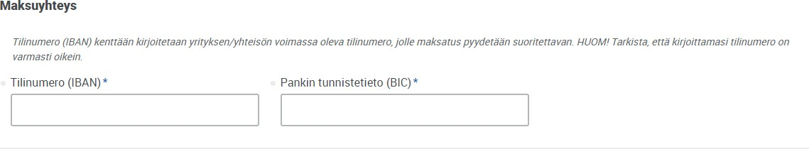

The current account number of the applicant company/entity for which payment is requested is entered in the “Maksuyhteys” (Payment details) field. Please check that the account number is correct.

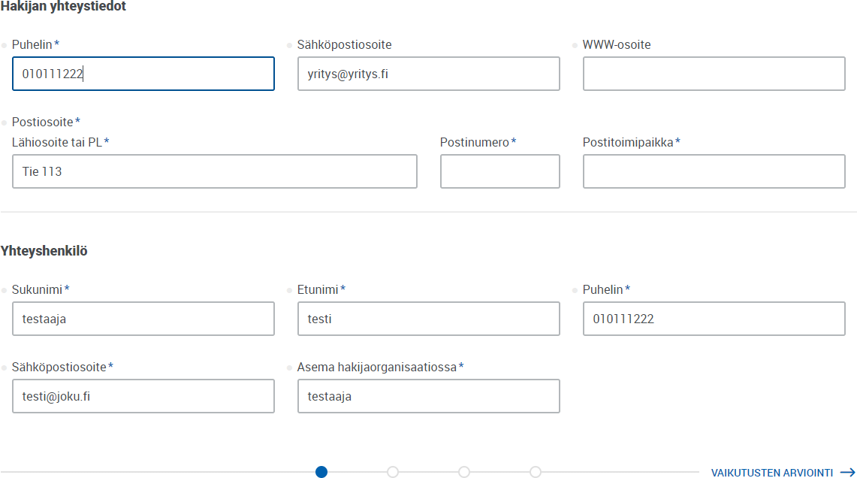

“Hakijan yhteystiedot” (Applicant contact details) refers to the contact details of the company/organisation. The following information may be imported automatically, but please check the information and make any necessary corrections.
It is important to have information for he designated application contact person in case they need to be contacted during the processing of the application. Any e-service alerts related to the application (notifications of arrival, requests for additional information) will be sent to the contact person’s email address.

"VAIKUTUSTEN ARVIOINTI” (Impact assessment) tab
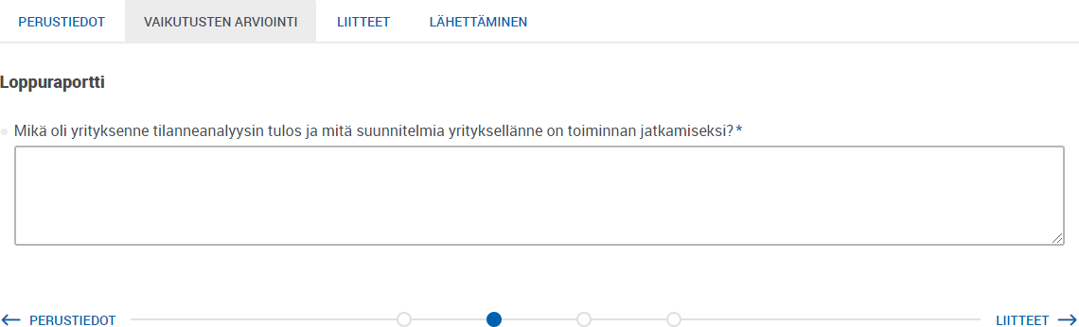

This text box is for the final report on the situation analysis. The purpose is to explain what the result of the situation analysis was and what plans your company has to continue its operations.

“LIITTEET” (Attachments) tab
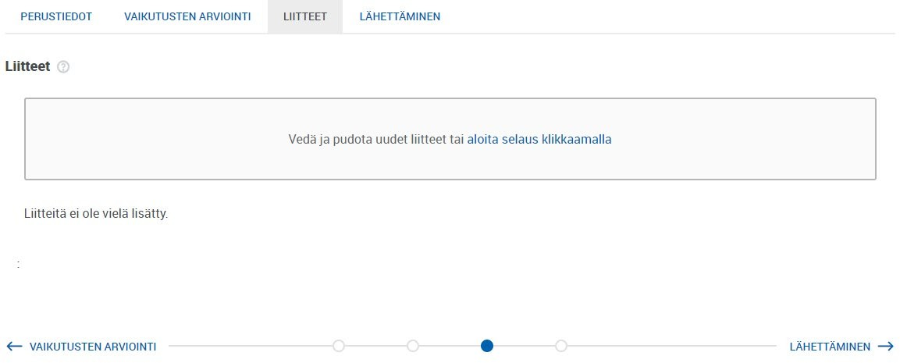

There are no mandatory attachments to the situation analysis, but you can attach, for example, materials generated through the situation analysis or other attachments necessary for processing the application for payment.

“LÄHETTÄMINEN” (Sending) tab

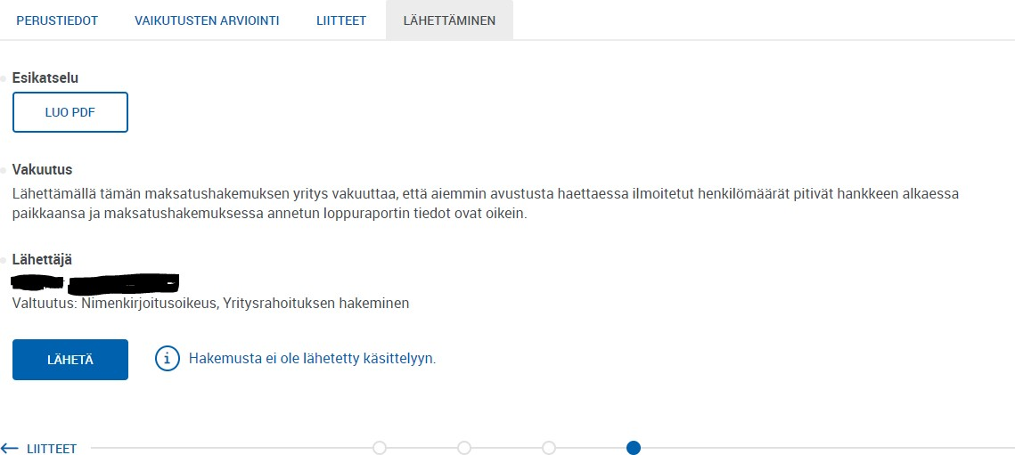

On the “Lähettäminen” (Sending) tab, you can preview the application for payment and send it by clicking the “Lähetä” (Submit) button. To submit your application, press the “Lähetä” (Submit) button. At this stage, the e-service will check the contents of the application. Any possible errors / missing information will be indicated in red, and you will not be able to submit your application until the information has been corrected/included.
PLEASE NOTE: By submitting an application for payment, the company declares that the personnel numbers reported earlier when applying for aid are still valid at the start of the project, and that the final report data given in the application for payment is correct.

After sending the application for payment
Once the application has been submitted, the applicant will receive in the e-service
- A confirmation of receipt. This is shown on the “Maksatukset” (Payments) page under “Vastaanotettu” (Received) and shows the time when the application was received.
- A notification of arrival. This message is sent after the official responsible for processing the application has marked the application as received. The notification of arrival states the official who is processing the application for payment.

An automated alert is sent to the email address of the application contact person in connection with both of the aforementioned notifications. If you do not receive this email, we recommend checking the email address you gave him the “Yhteyshenkilö” (Contact person) field as well as the junk folder of your email account.

Processing of application for payment
The official processing the application may need additional information from the applicant. The official can send a request for additional information to the e-service, which sends an automated alert to the contact person’s email address. The request for additional information is answered through the e-service, and the request for additional information is accompanied by a deadline by which the additional information must be submitted via the e-service.

Payment decision
After the official has made a decision on the application, the decision is sent to the applicant digitally via the e-service.

